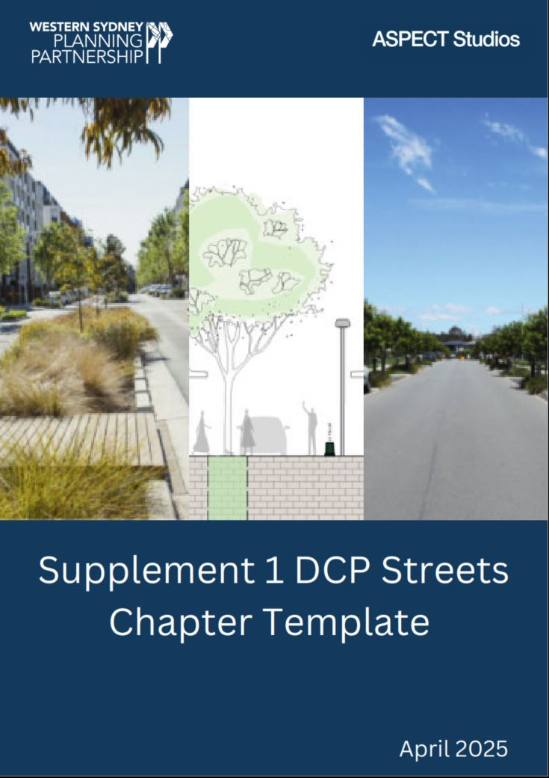
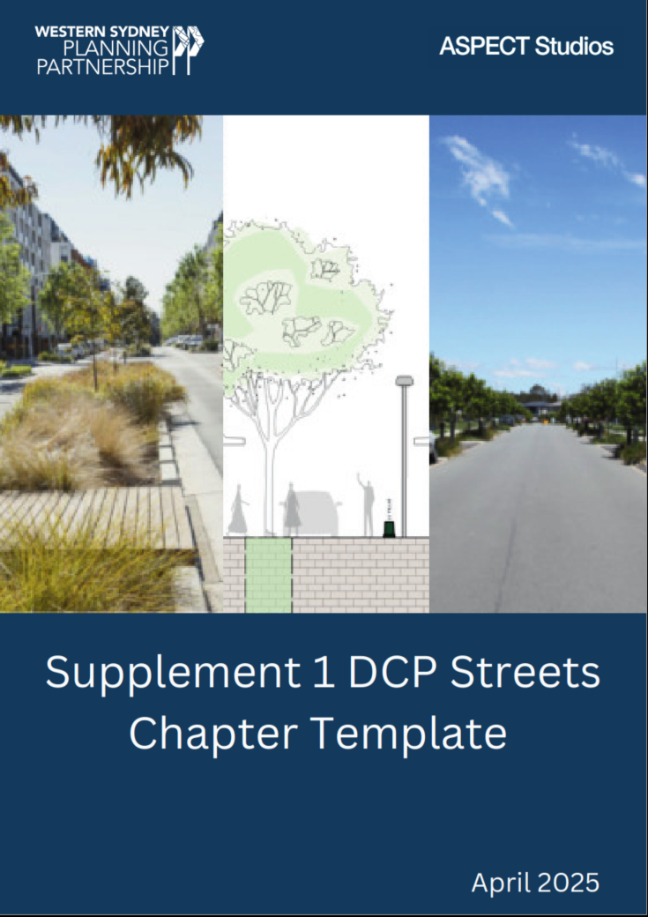

Street network and layout design

Objectives
- To integrate precinct and network planning with street design to ensure they are coordinated and working together to deliver better street networks and encourage mode shift from private vehicles to walking, cycling, and public transport;
- To emphasise the close coordination required between the street type choice, its detailed design, and the subdivision of lots or cadastral “Place” determinants, encouraging consideration beyond public domain ‘things’ within the street reserve like trees, to more integrated design along the street/lot interface;
- To create interesting and attractive streetscapes that contribute to the identity and amenity of every neighbourhood;
- To establish a legible network and interconnected hierarchy of self-explaining slow streetscape environments that provide safe, convenient, and clear access within and beyond the Precinct;
- To create safe, accessible, comfortable and attractive public transport, walking, and cycling networks;
- To assist in managing the environmental impacts of urban development including soil salinity, micro-climate effects, stormwater, and the retention of mature trees and significant vegetation;
- To ensure public safety from criminal elements by considering the NSW Police ‘Safer by Design’ or ‘Crime Prevention Through Environmental Design’ principles and protocols;
- To facilitate energy efficient lot and building orientation;

Controls

Controls for all street types
- The design and construction of streets is to be consistent with the relevant typical designs in Figure X to Figure X, the Western Sydney Street Design Guidelines, Council’s Engineering Specifications, and Austroads (where applicable).
- All street cross-sections illustrate minimum requirements. In particular circumstances, widths may need to be modified to respond to site-specific conditions, such as topography and the retention of remnant vegetation, or to incorporate additional design requirements such as water sensitive urban design measures.
- All streets which form part of a bus route identified by Transport for NSW are to have at least one travel lane in each direction with a minimum width of 3.5 metres, suitable for buses. Lanes which are not adjacent to a kerb may be 3.2m wide. Intersections on bus routes are to be designed to accommodate bus manoeuvrability.
- Alternative street designs for local streets and access ways may be permitted on a case-by-case basis if they preserve the functional objectives and requirements of the design standards presented herein and within the Western Sydney Street Design Guidelines, Council’s Engineering Specifications, and Austroads (where applicable).
- The locations and alignments of all streets are to be generally in accordance with the locations shown on the <insert cross reference to appropriate precinct street hierarchy figure if relevant>.
- Where any variation to the residential street network indicated in the <insert cross reference to appropriate precinct street hierarchy figure if relevant> is proposed, the alternative street network is to be designed to:
  - align with the intent and functional requirements of the Western Sydney Street Design Guidelines;
  - not detrimentally impact on access to adjoining properties;
  - provide for the management of stormwater to drain to Council’s trunk drainage network, without negative impacts on other properties;
  - not impede the orderly development of adjoining properties in accordance with the relevant Precinct Plan and this Development Control Plan;
  - not restrict the ability to provide water, sewer, electricity and other essential services to the development or to development on adjoining properties;
  - create a permeable network that is based on a modified grid system;
  - encourage walking and cycling;
  - maximise connectivity between residential areas and community facilities, open space, and centres;
  - take account of topography and site drainage, and accommodate the retention of mature trees and significant vegetation;
  - optimise solar access opportunities for dwellings and other buildings;
  - provide frontage to and maximise surveillance of open space and drainage lands;
  - provide views and vistas to landscape features and visual connections to nodal points and centres;
  - maximise the effectiveness of water sensitive urban design measures;
  - ensure that noise impacts from major roads are considered and are able to be effectively mitigated without the use of noise walls;
  - minimise the use of cul-de-sacs; and
  - comply with the requirements of Planning for Bushfire Protection 2006.
- Where streets are adjacent to public open space or drainage land, or adjacent to arterial, sub-arterial or transit boulevards, the verge width on the side adjacent to the open space, drainage land or major road may, in certain circumstances, be reduced to a minimum of 1m, subject to:
  - appropriate arrangements for the provision of public utilities;
  - provision of appropriate walking and cycling facilities within the adjacent open space, drainage land, or major road;
  - compliance with road safety requirements; and
  - acoustic attenuation, bushfire asset protection zone, and riparian corridor requirements.
- Where streets are located as per control 10 above, the parking bays or parking lanes may be provided on one side only providing the applicant can demonstrate to Council’s satisfaction that the street will operate safely and effectively. Street trees are still to be provided within both verges.
- Where streets are proposed as part of an application for subdivision that are located adjacent to public recreation land, drainage land, community facilities or schools, the applicant will be responsible for construction of the full width of the street.
- Private streets are to be designed and constructed in accordance with the Western Sydney Street Design Guidelines and Council’s Engineering Specifications. Details must be shown on the engineering design plans and must be submitted prior to the issue of the subdivision certificate.
- The design of streets is to take account of existing mature trees and significant vegetation.

Destination High Streets
Destination High Streets are to adhere to the following performance criteria:
Road reserve | ≥20m
Typical AADT | ≤10,000
Freight access | Service and delivery vehicles
Posted speed | 30-40km/h
Design speed | Same as posted speed
Design vehicle | B85 car
Check vehicle | Single unit truck/bus (12.5m)
Bus capable | Yes
Vehicle travel lanes | 2x 3.2m (+ 0.3m buffer for bus capability)
Parking provision | Varies
Parking arrangement | 2.3m indented parking bays
Walking | ≥3.0m footpaths on both sides
Cycling | Within travel lane
Traffic calming | ≤80m spacings
WSUD | Passive irrigation (low flow), Swale (high flow)
Tree canopy cover | 70% (nom.) – refer NSW Greener Neighbourhoods Guide
Permeability | ≥35%

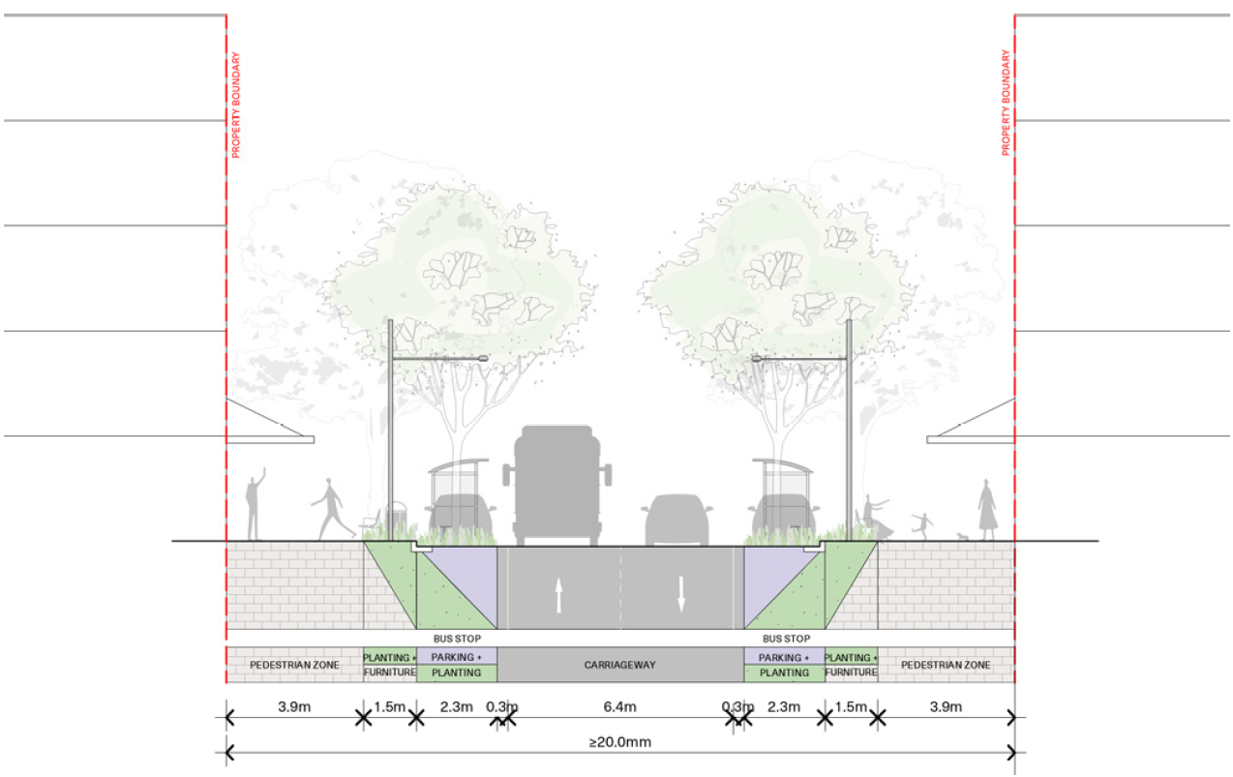
Figure X – Destination High Street typical cross section

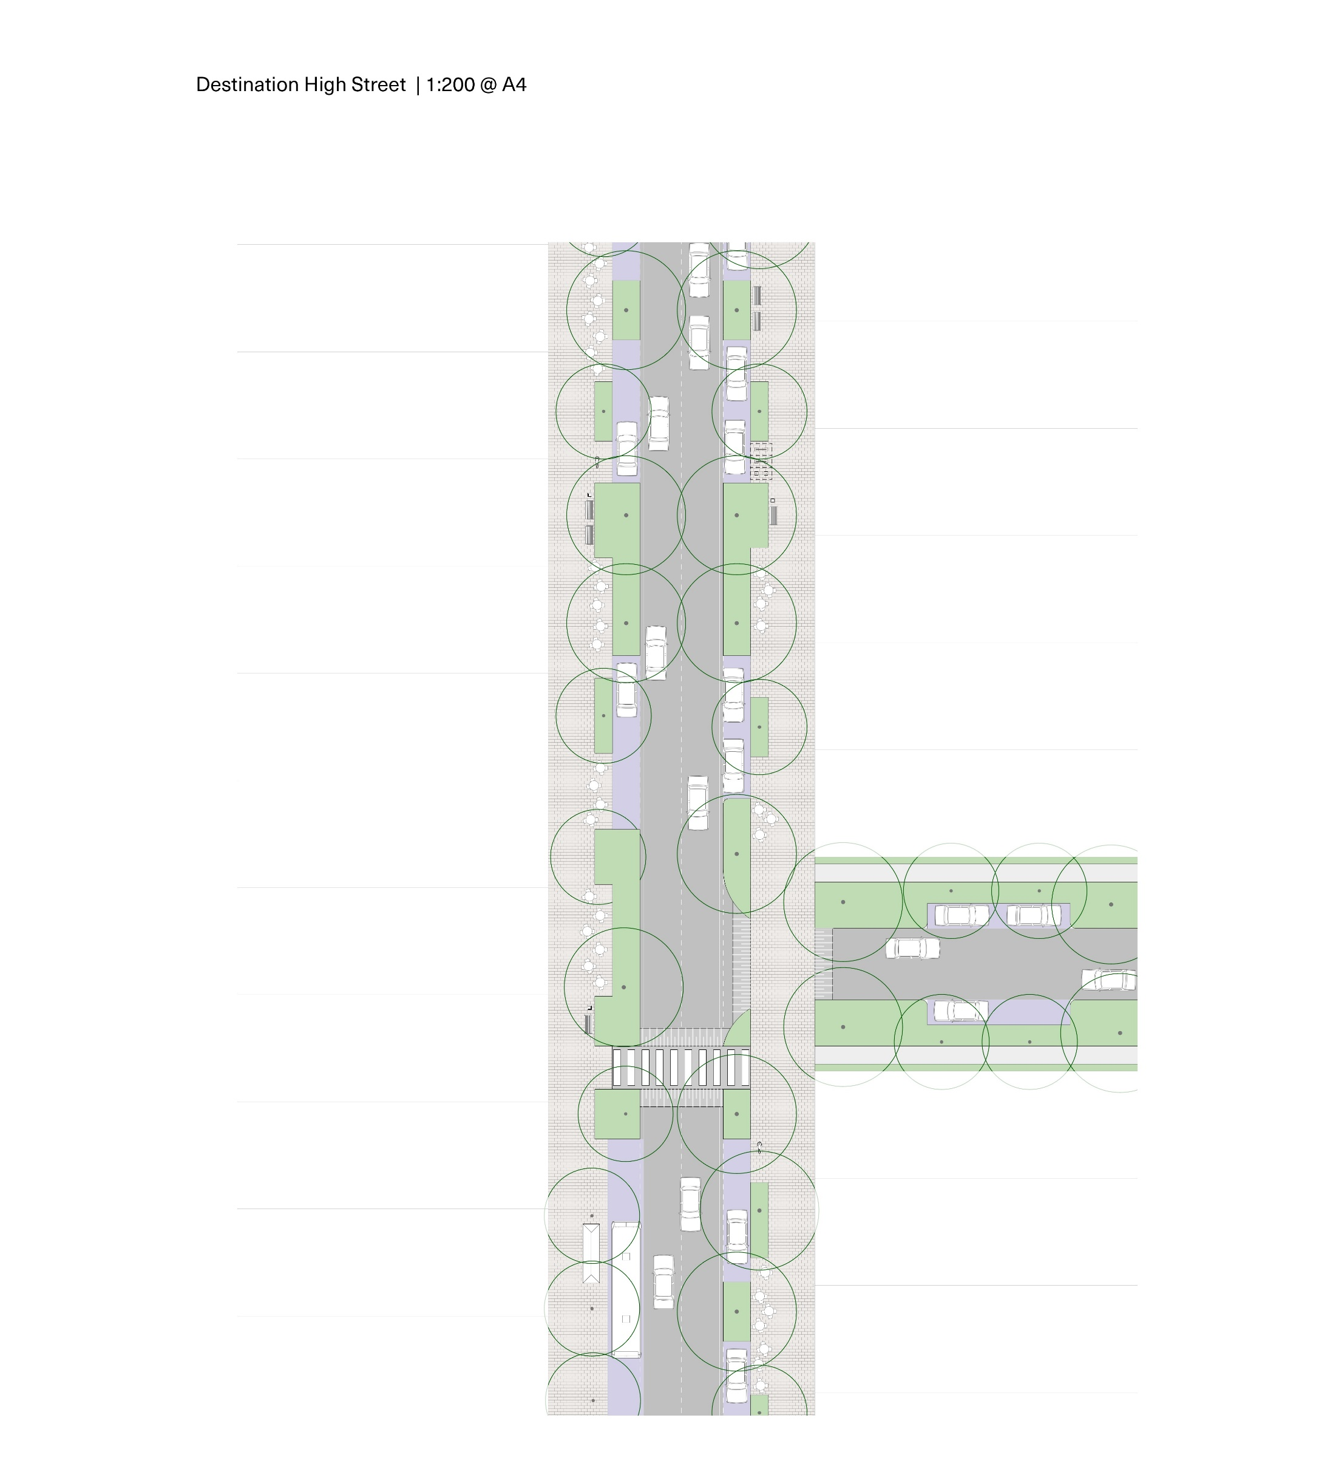

Figure X – Destination High Street typical plan

Enterprise Streets
Destination High Streets are to adhere to the following performance criteria:
Road reserve | ≥ 21.5m
Typical AADT | 1,000 - 4,000
Freight access | Service and delivery vehicles
Posted speed | 40-50km/h
Design speed | Same as posted speed
Design vehicle | 19m semi-trailer
Check vehicle | 19m semi-trailer
Bus capable | Yes
Vehicle travel lanes | 2 x 3.2m (+ 0.3m buffer for bus capability)
Parking provision | Varies
Parking arrangement | 2.3 - 3.0m indented parking bays (widen if needed for design vehicle such as freight/delivery vehicles to park without encroaching in travel lane)
Walking | 1x ≥1.5m footpath + 1x ≥3.0m shared path
Cycling | 1x ≥3.0m shared path
Traffic calming | ≤80m spacings
WSUD | Passive irrigation (low flow), Swale (high flow)
Tree canopy cover | 60% (nom.) – refer NSW Greener Neighbourhoods Guide
Permeability | ≥35%

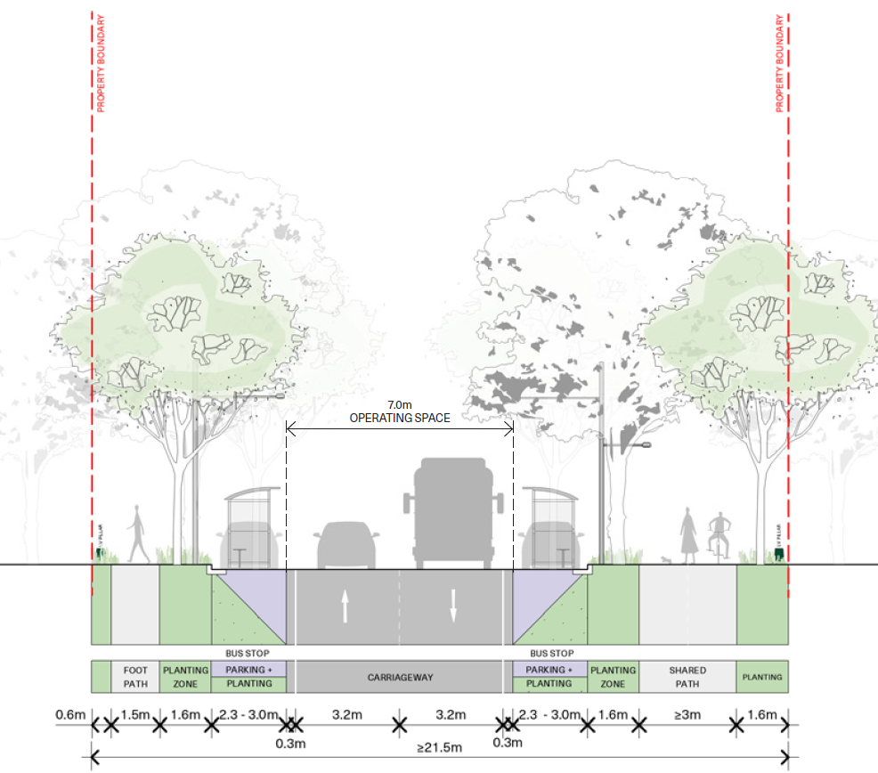
Figure X – Enterprise Street typical cross section

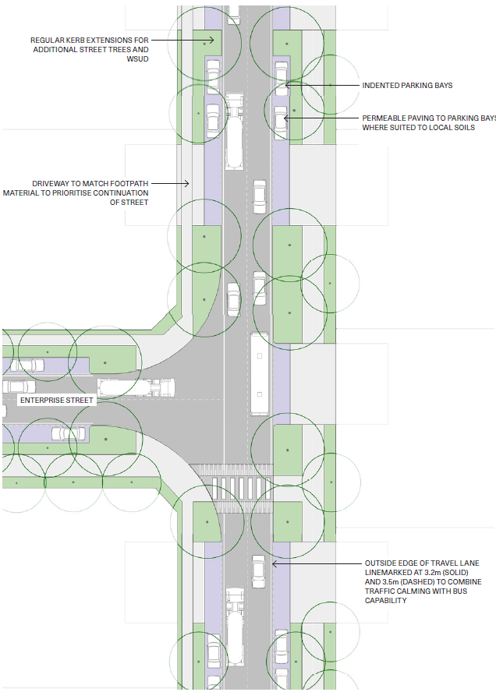
Figure X – Enterprise Street typical plan

Urban Centre Streets
Urban Centre Streets are to adhere to the following performance criteria:
Road reserve | ≥ 21.5m
Typical AADT | 1,000 - 4,000
Freight access | Service and delivery vehicles
Posted speed | 40-50km/h
Design speed | Same as posted speed
Design vehicle | 8.8m service vehicle
Check vehicle | 8.8m service vehicle 12.5m bus (if on bus route)
Bus capable | Yes
Vehicle travel lanes | 2x 3.2m (+ 0.3m buffer for bus capability)
Parking provision | Varies
Parking arrangement | 2.3m indented parking bays
Walking | 1x ≥1.5m footpath + 1x ≥3.0m shared path
Cycling | ≥2.5m separated cycleway or 2x ≥1.5m unidirectional cycleways
Traffic calming | ≤80m spacings
WSUD | Passive irrigation (low flow), Swale (high flow)
Tree canopy cover | 70% (nom.) – refer NSW Greener Neighbourhoods Guide
Permeability | ≥35%

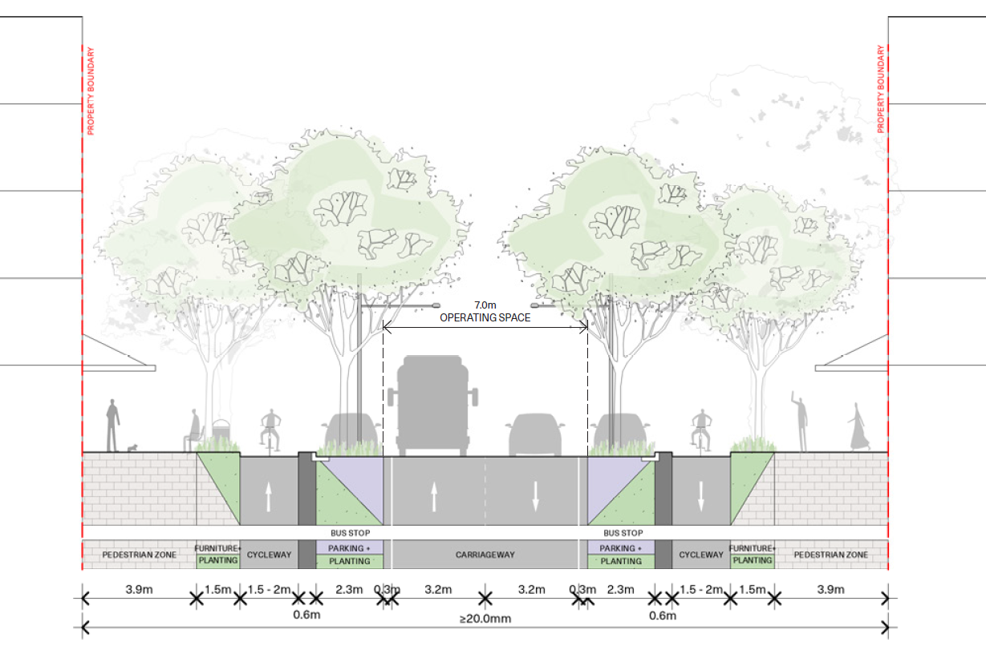
Figure X – Urban Centre Street typical cross section

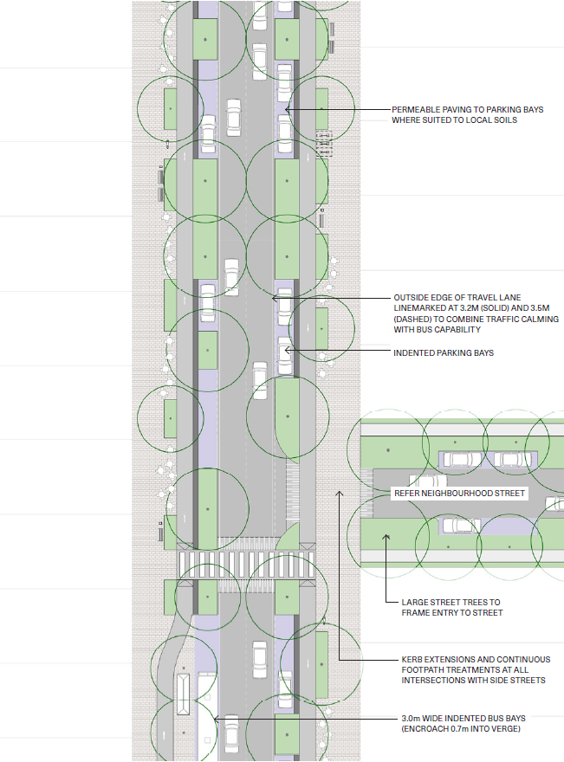
Figure X – Urban Centre Street typical plan

Connector Streets
Connector Streets are to adhere to the following performance criteria:
Road reserve | ≥21.5m
Typical AADT | 2,000 - 5,000
Freight access | Service and delivery vehicles
Posted speed | 40-50km/h
Design speed | Same as posted speed
Design vehicle | 8.8m service vehicle, 12.5m bus (if on bus route)
Check vehicle | 12.5m bus/truck
Bus capable | Yes
Vehicle travel lanes | 2x 3.2m (+ 0.3m buffer for bus capability)
Parking provision | Varies
Parking arrangement | 2.3m indented parking bays
Walking | ≥1.5m footpaths on both sides; or  1x ≥1.5m footpath + 1x ≥3.0m shared path
Cycling | ≥2.5m separated cycleway;  or 1x ≥3.0m shared path
Traffic calming | ≤80m spacings
WSUD | Passive irrigation (low flow), Swale (high flow)
Tree canopy cover | 70% (nom.) – refer NSW Greener Neighbourhoods Guide
Permeability | ≥35%

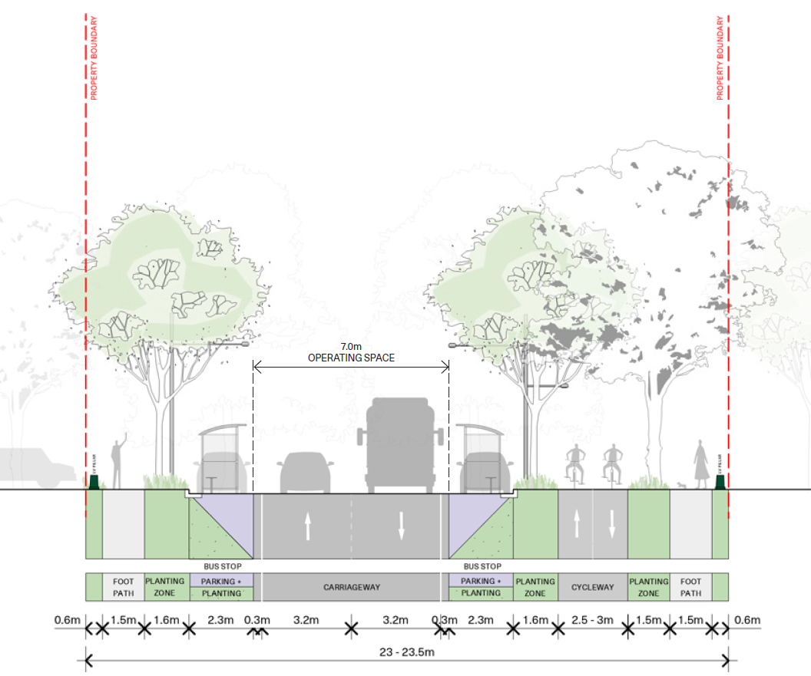
Figure X – Connector Street (with separated cycleway) typical cross section

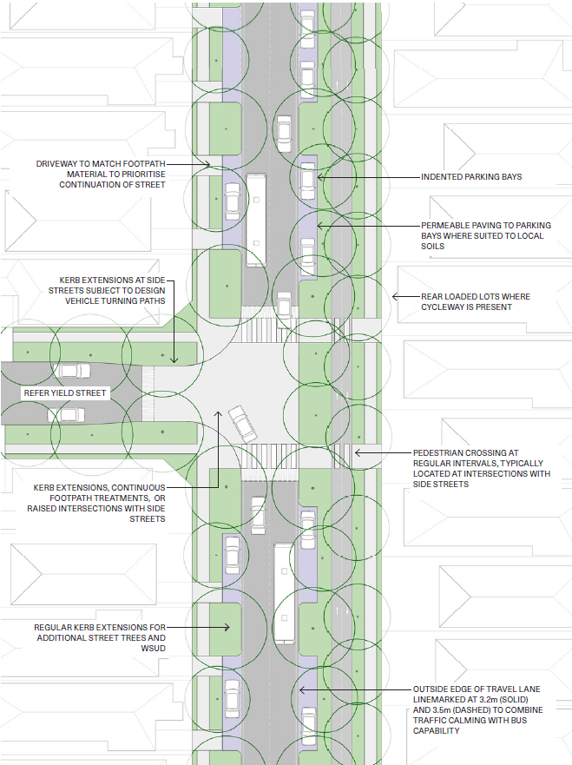
Figure X – Connector Street (with separated cycleway) typical plan

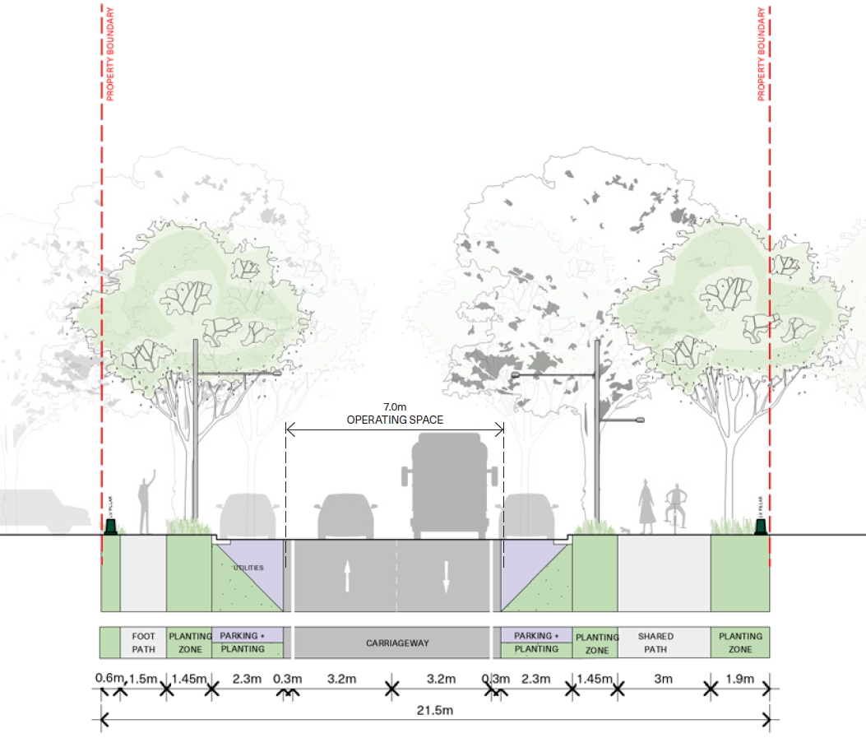
Figure X – Connector Street (with shared path) typical cross section

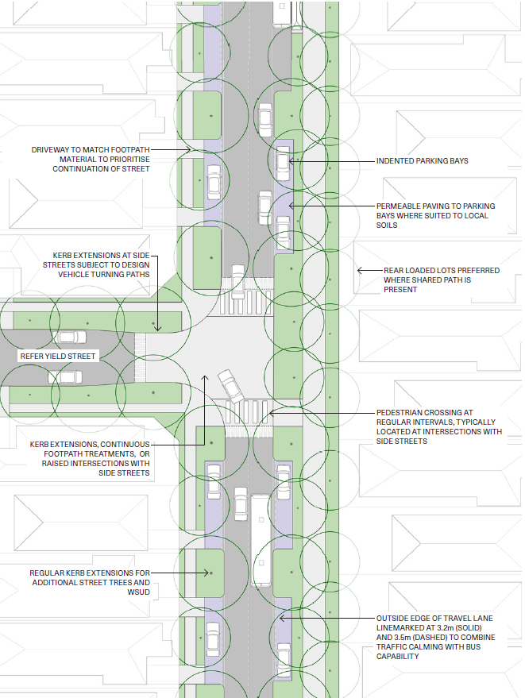
Figure X – Connector Street (with shared path) typical plan

Neighbourhood Streets
Neighbourhood Streets are to adhere to the following performance criteria:
Road reserve | ≥18m
Typical AADT | 500 - 2,000
Posted speed | 30-40 km/h
Design speed | Same as posted speed
Design vehicle | 5.3m passenger car
Check vehicle | 8.8m service vehicle, 12.5m bus (if on bus route)
Bus capable | Varies
Vehicle travel lanes | 2 x 3.0m (3.2m on bus routes)
Parking provision | ≤0.75 per lot
Parking arrangement | 2.1m indented parking bays
Walking | ≥1.5m footpaths on both sides
Cycling | Quietway - refer TfNSW Cycleway Design Toolbox
Traffic calming | ≤80m spacings
WSUD | Passive irrigation (low flow), Swale (high flow)
Tree canopy cover | 70% (nom.) – refer NSW Greener Neighbourhoods Guide
Permeability | ≥35%

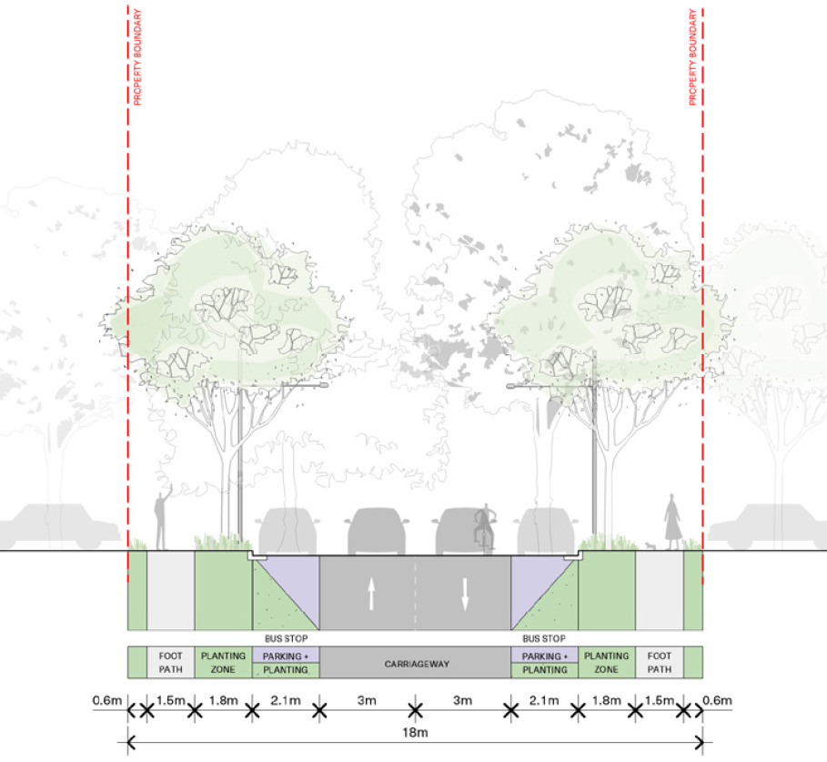
Figure X – Neighbourhood Street typical cross section

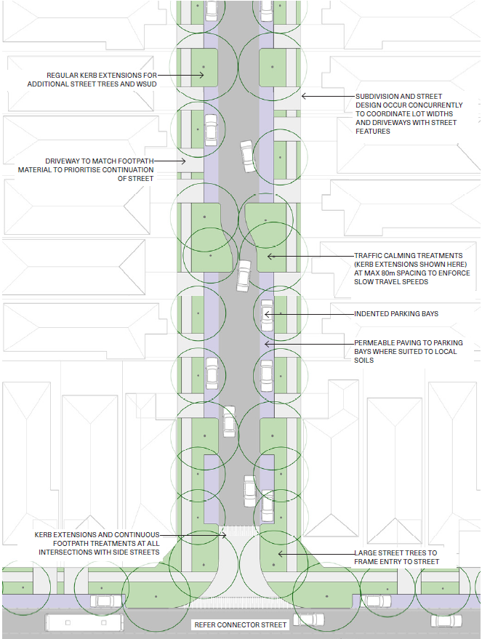
Figure X – Neighbourhood Street typical plan

Yield Streets
Yield Streets are to adhere to the following performance criteria:
Road reserve | ≥16m
Typical AADT | 500 - 2,000
Posted speed | 20-40km/h
Design speed | Same as posted speed
Design vehicle | 5.3m passenger car
Check vehicle | 8.8m service vehicle
Bus capable | No
Vehicle travel lanes | =7.6m kerb-to-kerb two-way carriageway
Parking provision | ≤0.75 per lot
Parking arrangement | Kerbside within carriageway to enforce yield for vehicles (no indented bays)
Walking | ≥1.5m footpaths on both sides
Cycling | Quietway - refer TfNSW Cycleway Design Toolbox
Traffic calming | ≤80m spacings
WSUD | Passive irrigation (low flow), Swale (high flow)
Tree canopy cover | 70% (nom.) – refer NSW Greener Neighbourhoods Guide
Permeability | ≥35%

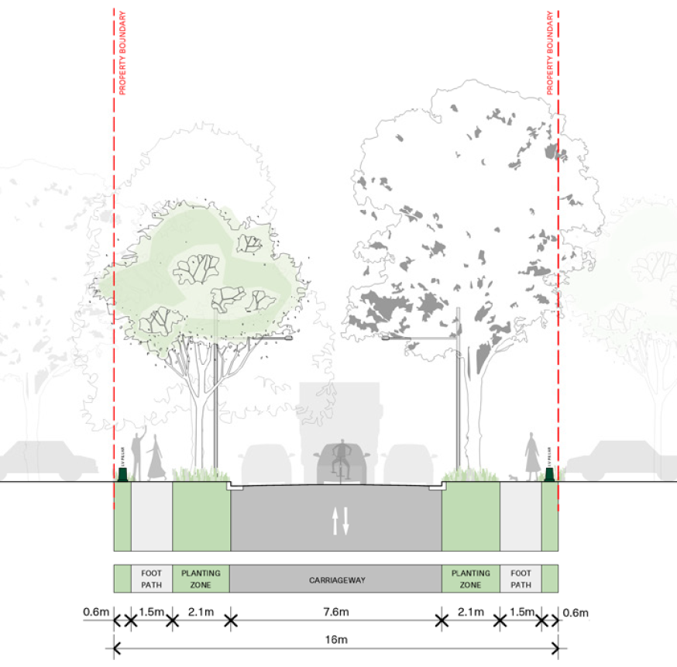
Figure X – Yield Street typical cross section

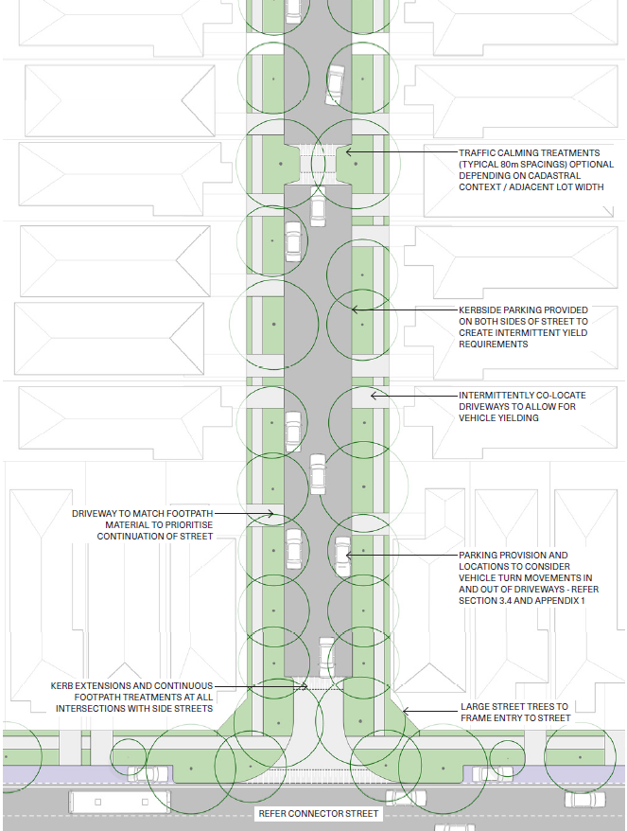
Figure X – Yield Street typical plan

Residential Ways
Residential Ways are to adhere to the following performance criteria:
Road reserve | ≥14m
Typical lots served | ≈10-15
Typical AADT | 100 - 1,000
Posted speed | 10-20km/h
Design speed | Same as posted speed
Design vehicle | 5.3m passenger car
Check vehicle | 8.8m service vehicle
Bus capable | No
Vehicle travel lanes | 5.6m one or two-way shared zone
Parking provision | ≤0.5 per lot
Parking arrangement | ≤2.4m indented parking bays  (with ‘parking in bays only’ signage)
Walking | 1.2m footpath and within shared zone
Cycling | Within shared zone
Traffic calming | ≤80m spacings
WSUD | Passive irrigation (low flow), Swale (high flow)
Tree canopy cover | 70% (nom.) – refer NSW Greener Neighbourhoods Guide
Permeability | ≥35%

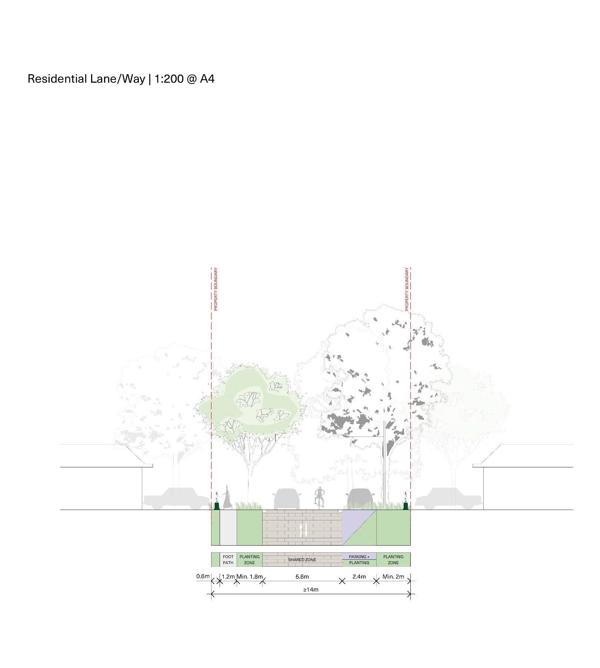
Figure X – Residential Way typical cross section

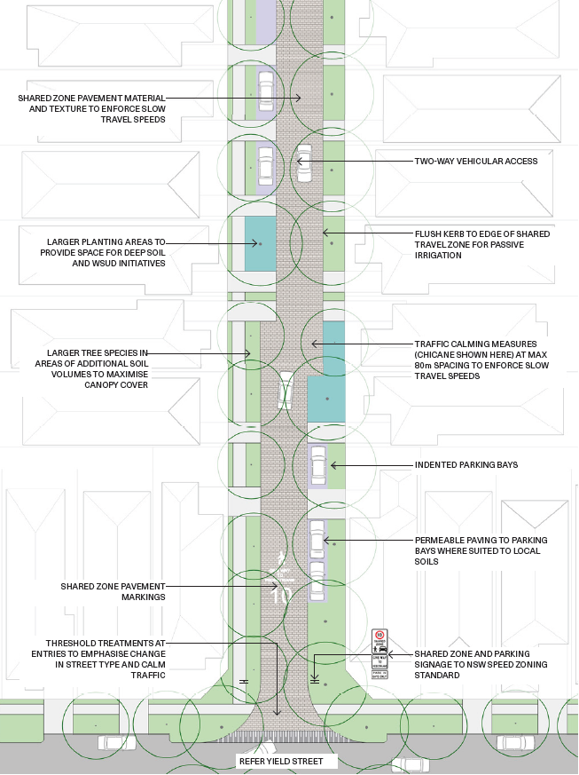
Figure X – Residential Way typical cross section

Residential Lanes
Residential Lanes are to adhere to the following performance criteria:
Road reserve | ≤8m
Typical lots served | 8-12m
Typical AADT | N/A
Posted speed | 10km/h
Design speed | 10km/h
Design vehicle | 5.3m passenger car
Check vehicle | 8.8m service vehicle
Bus capable | No
Vehicle travel lanes | ≥5.5m shared zone
Parking provision | Nil
Parking arrangement | N/A
Walking | Shared zone
Cycling | Two-way cycling within shared zone
Traffic calming | Shared zone
WSUD | Passive irrigation (low flow), Swale (high flow)
Tree canopy cover | 70% (nom.) – refer NSW Greener Neighbourhoods Guide
Permeability | ≥20%

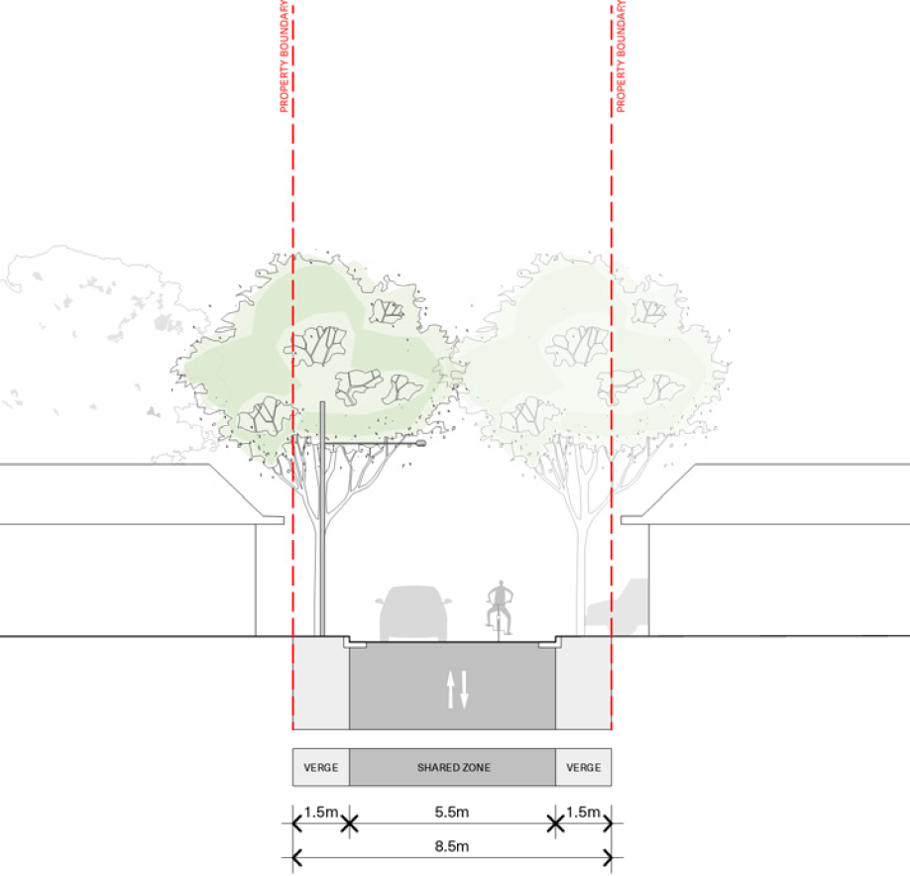
Figure X – Residential Lane typical cross section

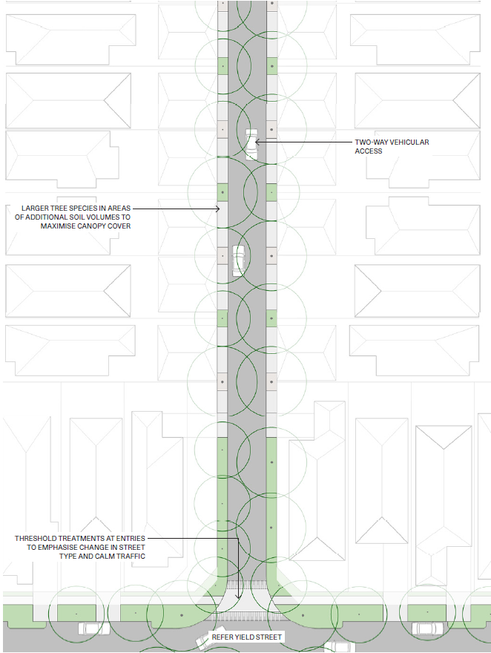
Figure X – Residential Lane typical plan

Civic Lanes
Civic Lanes are to adhere to the following performance criteria:
Road reserve | ≥7m
Posted speed | 10km/h
Design speed | 10km/h
Design vehicle | 5.3m passenger car
Check vehicle | 8.8m service vehicle
Bus capable | No
Vehicle travel lanes | One-way shared zone
Parking provision | As required
Parking arrangement | Interspersed with street trees
Walking | Shared zone
Cycling | Two-way cycling within shared zone
Traffic calming | Shared zone
WSUD | Passive irrigation (low flow), Swale (high flow)
Tree canopy cover | 40% (nom.) – refer NSW Greener Neighbourhoods Guide

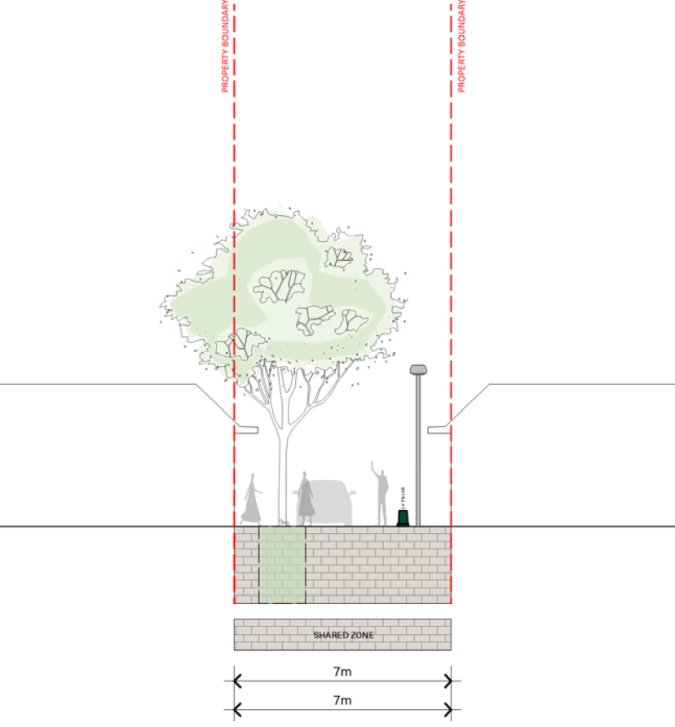
Figure X – Civic Lane typical cross section

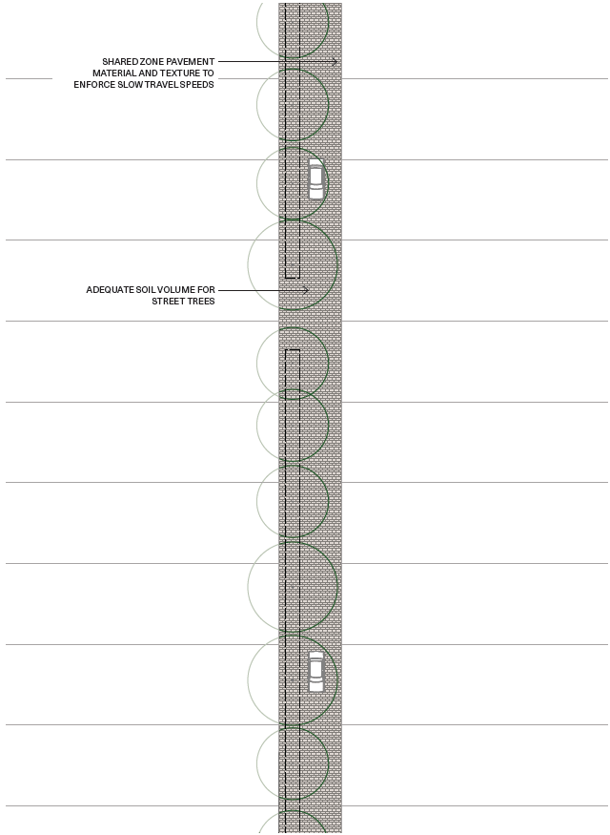
Figure X – Civic Lane typical plan

Transit Malls
Transit Malls are to adhere to the following performance criteria:
Road reserve | ≥18m
Typical AADT | Vehicle restricted
Freight access | Service and emergency vehicles (managed)
Posted speed | 10 - 20km/hr
Design speed | Same as posted speed
Design vehicle | Largest bus operating in space
Check vehicle | Same as design vehicle
Bus capable | Yes
Vehicle travel lanes | 2x 3.5m (for buses)
Parking provision | N/A
Parking arrangement | N/A
Walking | ≥3.0m footpaths on both sides
Cycling | Within travel lane (excluding light rail track zone)
Traffic calming | N/A
WSUD | Passive irrigation (low flow)
Tree canopy cover | 70% (nom.) – refer NSW Greener Neighbourhoods Guide
Permeability | N/A

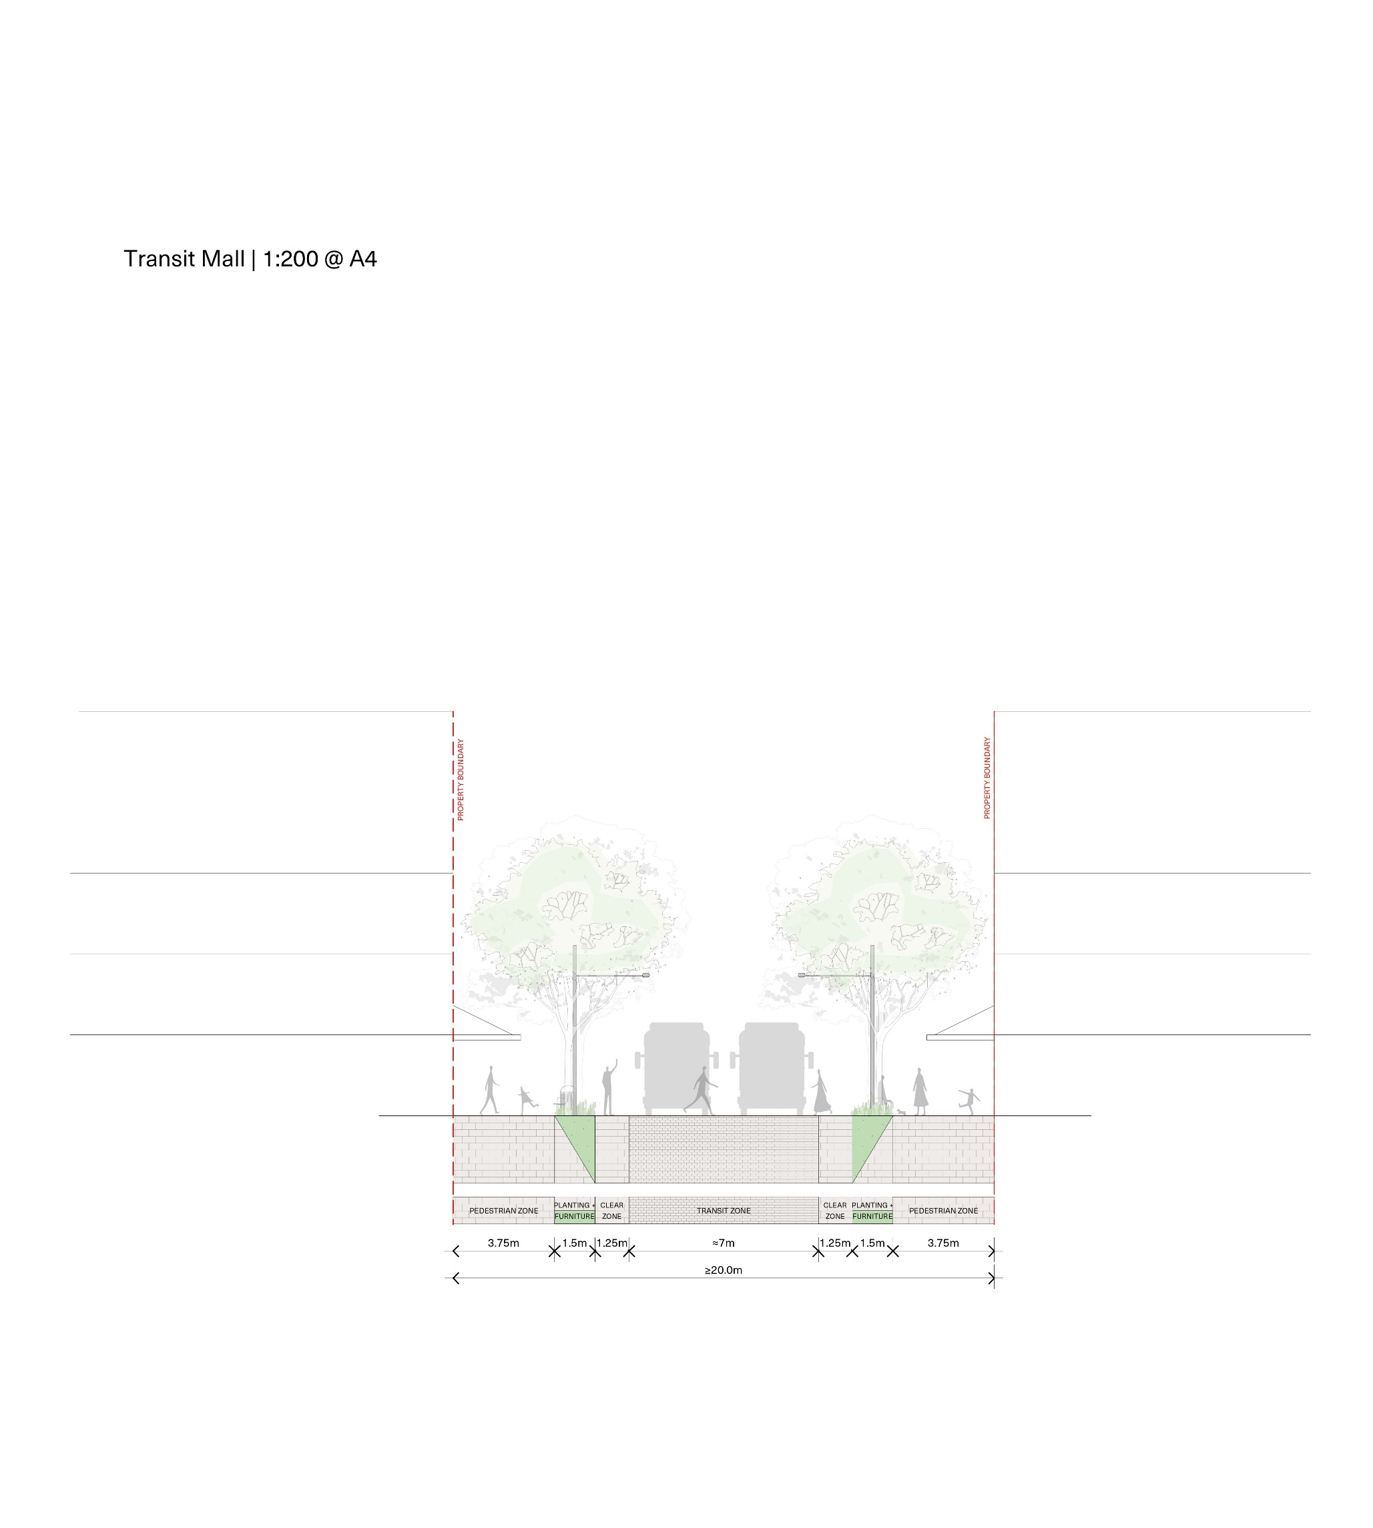
Figure X – Transit Mall typical cross section

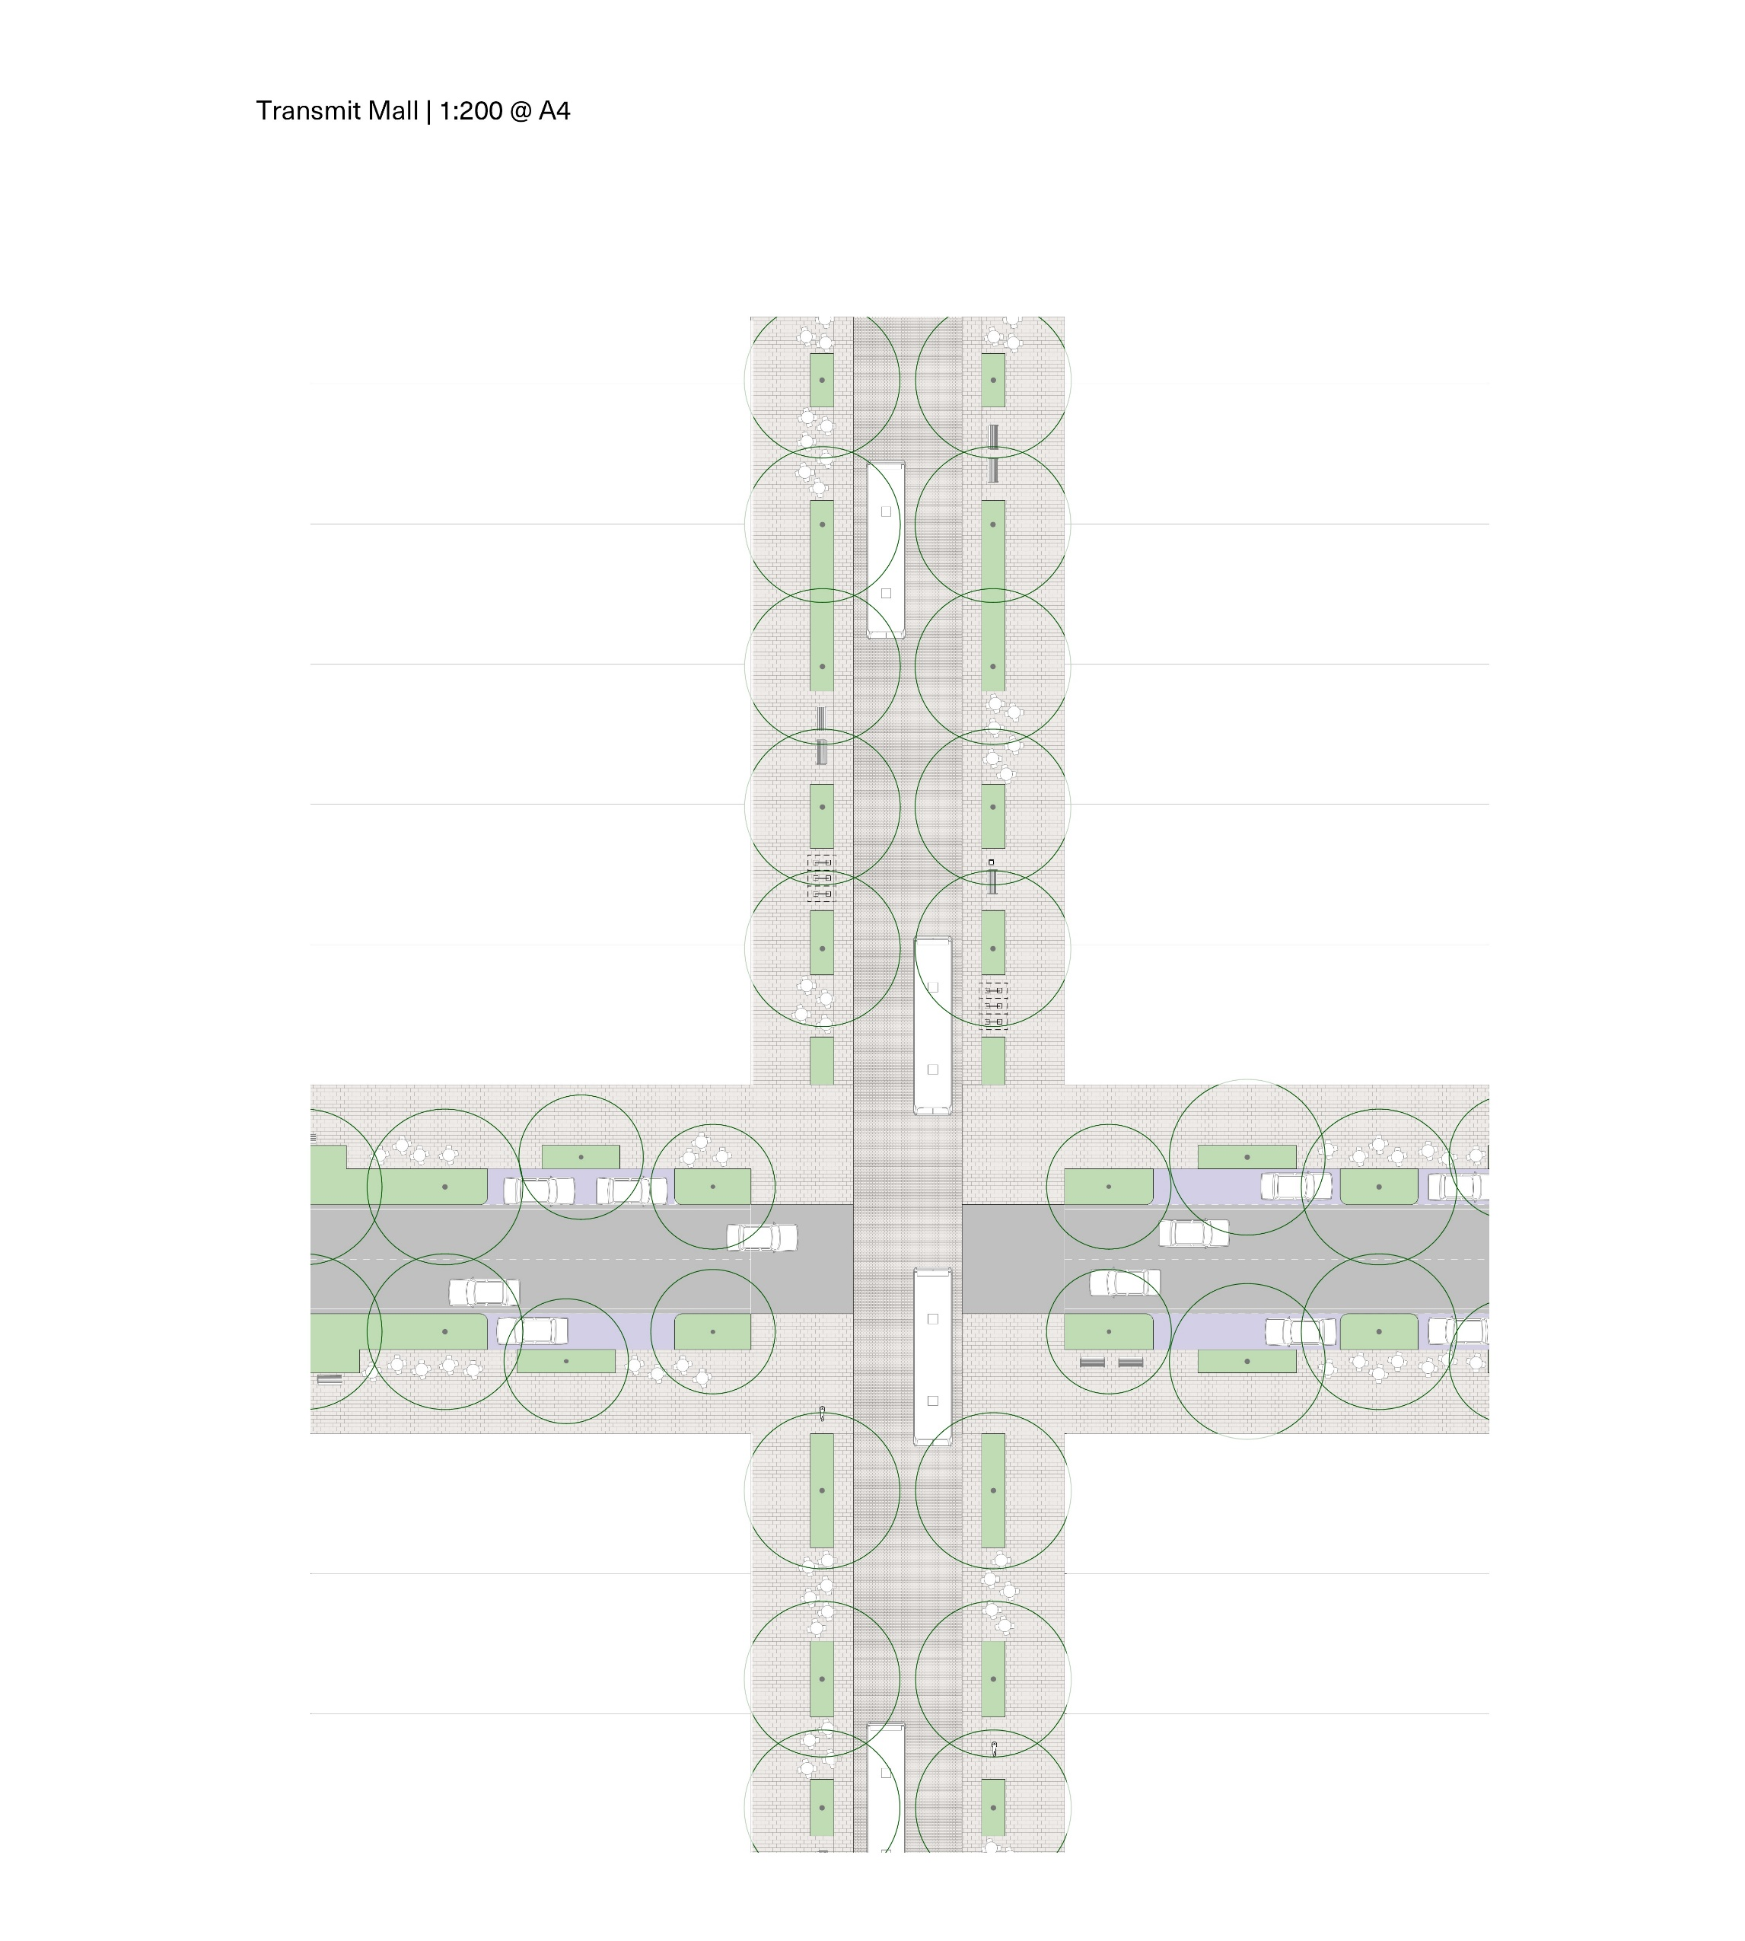
Figure X – Transit Mall typical plan

